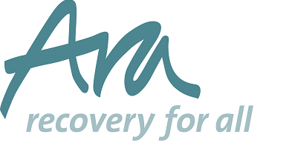
Could You Chair the Board of Trustees at Ara at this Exciting Time of Development?
Due to the end of tenure of our current Chair, we are searching for a dynamic individual who will lead the Ara Board of Trustees in the oversight of the delivery of our ambitious new strategic plan, “Springboard for Growth”
This plan will increase our financial performance, geographical expansion and ensure we achieve our purpose of “Making life better because we believe passionately that people can change and recover”
We are looking for someone to lead our experienced and dedicated Board of Trustees to achieve our vison of continuing to be a “vibrant organisation and by 2023 we will:- be working with 50% more beneficiaries; be financially robust with income from a diverse range of sources; increasingly collaborate with like-minded partners; be recognised nationally for excellence; be an employer of choice. As an organisation we will continue to innovate and will have expanded our services geographically.
As Chair you will provide inspirational board leadership whilst holding Ara and the Senior Team to account, challenging us to grow and improve whilst supporting us to be the best we can.
Ara is looking for an individual with the following key experience, attributes and skills:

- Commitment to Ara’s objects, aims and values and having the willingness and enthusiasm to devote time to carry out responsibilities.
- Understanding and acceptance of the legal duties, responsibilities and liabilities of trusteeship and adhering to the ‘Seven principles of public life’ : selflessness, integrity, objectivity, accountability, openness, honesty and leadership
- Strategic and forward looking, with vision in relation to Ara’s objects and aims.
- Objective and independent judgement, political impartiality and the ability to think creatively in the context of the organisation and the external operating environment.
- Good communication and interpersonal skills and the ability to respect the confidences of colleagues.
- The ability to balance tact and diplomacy with a commitment to challenge and constructively criticise when necessary.

The post is not remunerated but reasonable expenses will be reimbursed.
To apply, please tell us of the skills and experience you will bring to this role and enclose a C.V if you have one. Send to our Chief Executive, Graham England at grahamengland@recovery4all.co.uk

The closing date for the application is:
Monday 8th October 2018 – 5pm
Interviews are on the 18th October 2018 to be held at our head office at Kings Court, Kings Street, Bristol, BS1 4EF
For an informal discussion about this exciting opportunity please speak to our Chair Patsy Hudson on 07780 934969
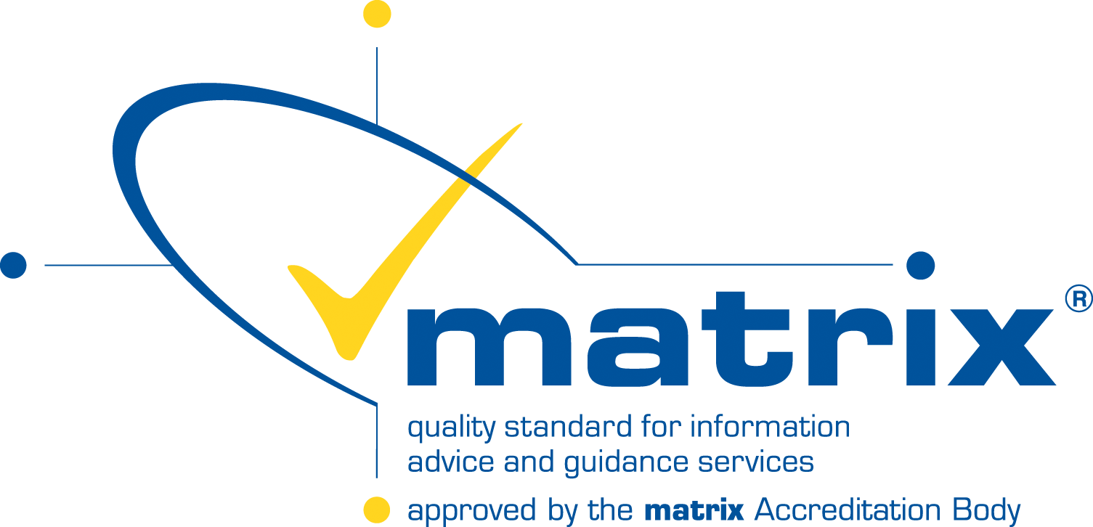

.

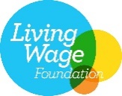
Charity no. 1002224 | Limited company no. 2540814

