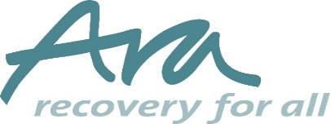

Purpose Vision, and Values

Purpose: We make life better because we believe passionately that people can change and recover.

Vision: We are a vibrant organisation and by 2023 we will :- be working with 50% more people; financially robust with income from a diverse range of sources; increasingly collaborate with like minded partners; be recognised nationally for excellence; be an employer of choice. As an organisation we will continue to innovate and will have expanded our services geographically.

Values: Our staff teams, volunteers, managers and board members, are:

- Passionate
- Dynamic
- Enduring
- Respectful
- Professional
- Supportive

Behaviours that underpin our values

Passionate and courageous, determined and committed to our services users, we are enthusiastic innovators, creating and developing recovery focussed service. We are prepared to go above and beyond to ensure service users achieve their desire for change.

Dynamic and capable, able to make our own decisions, and show leadership throughout the organisation. We are excellent problem solvers, becoming multi-skilled by having a willingness to learn and then to teach others. We have ambition for all of our service users. We will work in collaboration with partners to ensure we deliver to the highest standards.

Enduring and committed to our service users, we are reliable and are flexible to meet changing environments and conditions. Innovation of new services will achieve our purpose, vision, and long term sustainability.

Respectful of all stakeholder needs, we are open minded to different view points, however we are committed to anti-discrimination, challenging it wherever we find it. We focus on equality and diversity, strongly believing in fairness and dignity. We work tirelessly to help service users take control of their lives in a sustainable way

Professional, effective and efficient, using our resources wisely to achieve our vision and services user’s ambitions. We are honest and prepared to admit our mistakes and learn from them. We act with integrity and are accountable in all of our actions

Supportive and caring, we strive to be friendly, approachable, and helpful. We are patient and treat everyone with compassion and kindness

