JOB DESCRIPTION

Job Title: Chief Operations Officer
Responsible To: CEO
Based: Ara Head Office, Bristol
Salary: £45,000

SCOPE OF THE JOB

We are looking for a Chief Operations Officer to organise and oversee the daily operations of our charity. You will be the person to ensure that our Charity is well-coordinated and productive by managing its procedures and coaching it’s people.
The area of responsibility for this role is very wide and thus requires thorough knowledge of Ara’s various service processes.
The ideal candidate must be an exceptional organiser and able to plan many different kinds of operational activities. You must be an excellent leader who can discover the most efficient ways to run the business.
The goal is to safeguard and augment the efficiency of Ara’s operations to facilitate accelerating development and long-term success.

MAIN RESPONSIBILITIES OF THE JOB

- Liaise with CEO and Finance Director to set strategic goals and make decisions for new operational activities;
- Contribute to the continued corporate development of Ara, coordinating key areas as directed by and agreed with the Chief Executive;
- Provide visible leadership for all staff and be a role model of our values. Lead and champion an empowered leadership style which maximises team performance to enable the best possible recovery outcomes and develop the skills and capabilities of the operations teams to ensure there is a talent pool to meet the needs of the Strategic Plans;
- Plan and monitor the day-to-day running of Ara’s Services to ensure smooth progress;
- Supervise managers from different services in the charity and provide constructive feedback
- Evaluate regularly the efficiency of business procedures according to Ara’s strategy and contractual objectives and apply improvements;
- Provide operational leadership and direction in respect of quality and client safety, operational and cost efficiency, health & safety, risk management and strategic delivery;

- Ensure robust arrangements are in place to deal with governance issues across all services, ensuring that the highest standards of corporate and clinical governance are maintained;
- Lead on Ara’s business continuity plans ensuring they are effective, tested and understood and aligned with partners. Be the accountable lead for contingency & business continuity planning on behalf of Ara, supporting the delivery of safe, effective care ;
- Ensure that accurate, relevant and timely performance information is provided to the Chief Executive, SMT and Chair of the Board (and others as required) to enable early management of risk. Support action to maintain outstanding performance across all areas of the balanced scorecard;
- Manage tendering and bid writing processes, coordinate resources allocation;
- Oversee service user support engagement and feedback processes to enhance customer satisfaction and improve outcomes;
- Review financial information and adjust operational budgets to generate surpluses;
- Revise and/or formulate policies and promote their implementation;
- Manage relationships/agreements with external partners/commissioners;
- Evaluate overall performance by gathering, analysing and interpreting data and metrics;
- Support the CEO in ensuring that all statutory obligations are met and individual accountability for ensuring regulatory and statutory compliance.

Person Specification

EXPERIENCE & QUALIFICATIONS:

- Proven experience as Chief Operations Officer or equivalent position
- Ability to use and develop data analysis and performance/operation metrics
- Familiarity with MS Office and various business software (e.g. Enterprise Resource Planning Customer Relationship Management)
- BSc/BA in business administration or relevant field; MSc/MA will be a plus

SKILLS & KNOWLEDGE:

- Knowledge of the legal guidelines and responsibilities of the charity
- In depth knowledge of diverse business functions and principles (e.g. customer service etc.)
- Excellent organisational and leadership abilities
- Outstanding communication and people skills

PERSONAL CHARACTERISTICS:

- Commitment to Ara’s Values and Principles
- Commitment to Ara’s ongoing reputation for inclusivity and diversity
- Passion for and understanding of the role and vision of the charity and its commitment to passionately believing that people can change and recover

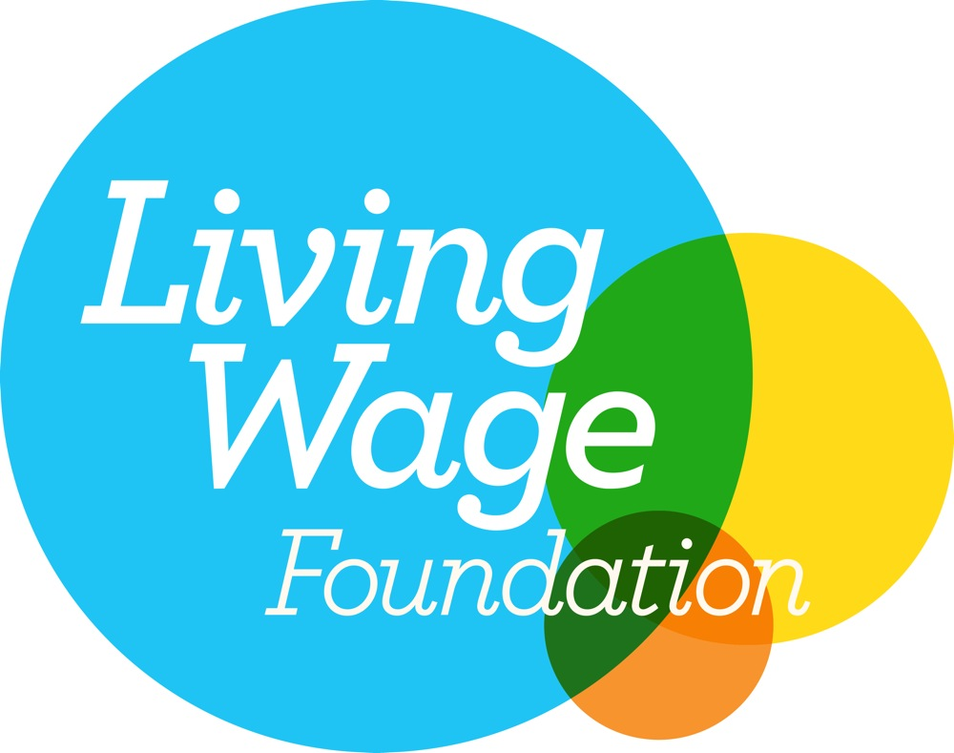



www.recovery4all.co.uk
Charity no. 1002224 | Limited company no. 2540814

