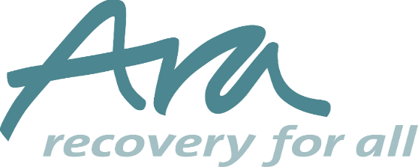

Prison worker Person Specification
EXPERIENCE OF:
- Inter-agency/ partnership/ collaborative working
- Delivering support to vulnerable people such as people with drug/alcohol dependency; mental health related needs; offenders/ex-offenders; young vulnerable people; rough sleepers
- Networking with housing providers including private landlords; statutory agencies ; RSLs and voluntary organisations
- Conducting client assessments and developing support plans
- Working in a supported housing setting and/or prison setting
SKILLS and KNOWLEDGE NEEDED:
- NVQ level 3 or similar in housing/ health and social care/ substance misuse
- A thorough understanding and up to date knowledge of the welfare benefits system
- A commitment to anti-discriminatory practice with an understanding of equal opportunities, social inclusion and diversity
- Effective verbal and written skills
- Good partnership and networking skills and a clear understanding of multi-disciplinary working
- Ability to work on own initiative and manage own caseload
- Ability to be self- servicing re administration and the use of IT
- Ability to form and sustain trusting relationships with clients
- An understanding of ‘duty of care’ in relation to safeguarding vulnerable adults and child protection
- Understanding the connection between stable housing and meaningful struture
PERSONAL CHARACTERISTICS
- Tactful, diplomatic and assertive. Able to maintain professional boundaries with clients
- Self motivated and able to work under pressure
- A clear understanding of team working
- Good at organisation and time management
- Able to use own initiative
- Conscientious and committed to the goal of excellence
- An understanding of confidentiality and willingness to resect operational guidelines on confidentiality
- Flexible approach to tasks
- Driving licence and access to a car (not essential)
- Willingness to work in collaboaration and close partnership with other organisations

